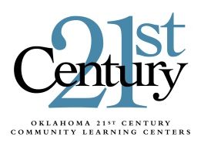
Oklahoma State Department of Education
21st Century Community Learning Centers
Grants Management Credentials Request
For Community-Based Organizations

Complete this form to obtain access to the Grants Management System website. This secured website hosts the Grants Management System for 21st Century Community Learning Centers (CCLC) application.

Organization EIN

Authorized Official of Organization Contact Information:

Name Position

Address 1 Address 2

City County Zip

Phone Email

Website

The following signature certifies that the above individual is authorized to bind the organization to the terms of the application and any subsequent requests for expenditure reimbursements.

Signature of Authorized Official Date

In addition to the account that will be issued for the authorized official, please issue accounts for the following person within the organization to allow data entry only.

Name

Position in the Organization

Phone Email

Name

Position in the Organization

Phone Email

Please scan and email this completed form to sonia.johnson@sde.ok.gov in the 21st CCLC office at the Oklahoma State Department of Education. OSDE will contact the authorized official with an assigned login and instructions.
FOR OFFICE USE ONLY
County District Code: . | Username 1: . | Password 1: .
Credentials Approved: . | Username 2: . | Password 2: .
Official Contacted: . | Username 3: . | Password 3: .

