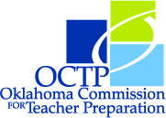
OKLAHOMA READING TEST PASS RATES

Aggregate Pass Rates by Major and Attempt*
September 2012 – August 2013

________________________________
Name of Institution

 | 1st Attempt |  | Overall
Major | N | %Pass | N | %Pass
Early Childhood
Elementary Education
Special Education
Other (i.e. Early Childhood/Special Ed):

Total

_____________________________ _________________
Submitted by Date

* Due to OCTP by October 1st of each year

